Richmond Review

Letting kids play
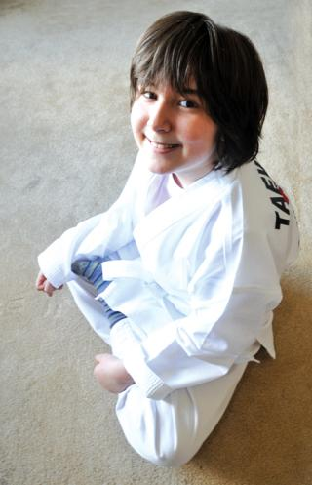
With the help of the Let Kids Play Foundation, Lindsay Folland was able to take classes for the first time.
Mark Patrick photo

Buy Richmond Review Photos Online
By Nathalie Heiberg-Harrison - Richmond Review
Published: April 25, 2009 1:00 AM
Updated: April 25, 2009 8:34 AM
Lindsay Folland loves a lot of things. She loves her MP3 player. She loves the Discovery Channel, where she watches shows like Man vs. Wild and Destroyed in Seconds. She loves Club Penguin, an online gaming site where she creates a penguin character, lives in an igloo and plays games to collect gold coins.
But the Hamilton Elementary student, who is one of the approximately 300,000 Canadians with fetal alcohol spectrum disorder, has never been inclined to include sports on the list of things she loves. Although the nine-year-old is full of nearly non-stop energy, harbouring it in a sports environment can be a stressful and wearing process.
“It makes it hugely, hugely difficult to get (Lindsay) involved in sports because, you know, who wants to go to something they fail at? That’s what ends up happening, and it gets really disheartening because all she wants to do is fit in,” her mother Julie said.
Gail Wilson, a senior professor in University of B.C.’s school of human kinetics, said that sports aren’t a one-size-fits-all solution to getting children active, and that this mentality is what stops many children from getting involved.
“Students who are quite athletically gifted will have fun,” Wilson said.
“Their self-esteem will be improved in those situations, and those less willing to participate who haven’t had positive experiences in physical activity environments will be less likely to take part unless we tailor the learning environment to suit their developmental characteristics.”
That tailored learning environment was just what Julie Folland was looking for, but because of Lindsay’s specific needs and their family’s stretched resources, they hadn’t found anything that fit quite right yet.
That is, until they found the support of the Let Kids Play Foundation, a charity that gives families in need the means to enroll their children in sports.
“The Let Kids Play program has been a real kind of godsend for us,” Julie said.
With their funding, she was able to place Lindsay at the Kikara Martial Arts Academy where she got started learning the basics of the sport. She is now at the Sonfire Taekwondo Academy of Richmond—a family-friendly martial arts school that mixes children’s games with the traditions of taekwondo: respect, discipline, honesty, integrity, positivity and friendship building.
Julie said that it’s a relief to finally find a sport that lets Lindsay be active and feel included and safe. In a sport like martial arts, where the focus is less on competition and more on self-discipline and hard work, Lindsay finally feels like she fits in. Julie says it gives her the confidence that she’s mastered and overcome something, something that is a huge moral victory.
Wilson said martial arts is a great alternative to team games for children not ready to play in organized sports yet.
“It allows (them) to succeed because they’re not having to worry about five teammates and opponents and a ball that’s moving at very fast speed.”
Julie agreed, and is already seeing big successes with Lindsay.
“It’s not like in hockey where you have to beat out a whole bunch of people. The challenge is against yourself and within yourself.”
Julie said that without the funding from the Let Kids Play Foundation, Lindsay simply wouldn’t be able to take part. Because of Lindsay’s changing needs in the past year, she’s had to take time off of work, so organized sports were just out of the question.
“If it hadn’t been for their support, she wouldn’t be in it because I can’t give all that to her, not yet. I’d really like to be able to take her to Disneyland, but right now I have to focus on making sure she’s OK,” Julie said.
“She’s an awesome girl and can go far in life if she’s got the proper support. There’s a silver lining like this every now and then that kind of keeps us going,” Julie said.
Julie said she hopes Lindsay’s involvement in sports will help her build her self-confidence and allow her to interact with peers she wouldn’t necessarily get the chance to interact with.
“If she feels included and has a good time, then she’ll feel more inclined to venture forward and, you know, maybe try other things,” she said, “because, you know, if you don’t have any successes it makes it very hard to want to jump in.”

